A mild winter and growth in the renewable energy sector contributed to a 2.5 % reduction in the European Union’s greenhouse gas emissions for 2011, even as the EU’s gross domestic product (GDP) increased, according to the most recent estimates from the European Environmental Agency (EEA).

The greatest reduction came from the 15 member states committed to the Kyoto Protocol (EU-15), which showed a 3.5 % decline in emissions from 2010 to 2011.

The new figures mean that EU emissions during 2011 were more than 17% below the 1990 level, while the EU-15 came in approximately 14% below the Kyoto base-year level.

*[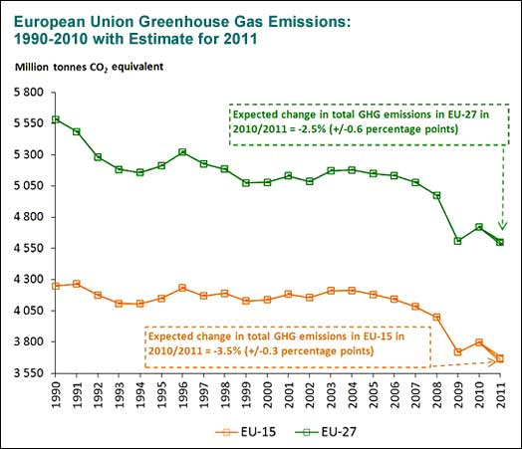](http://www.ecology.com/wp-content/uploads/2012/09/eu-emissions-2011estC-524.jpg)*

*Source: European Environmental Agency*

Economic sectors not covered by the EU Emission Trading System (EU ETS) reduced greenhouse gas emissions by approximately 3.1% in 2011, while emissions under the EU ETS fell by 1.8 %.

Sectors most responsible for the year’s decline were households and services. Transportation also contributed by reducing emissions for the fourth consecutive year.

Preliminary data released by the EEA in June indicated that CO2 emissions from new vehicles declined 3.3% in 2011. Average CO2 emissions for the 12.8 million new cars was 135.7 grams/kilometre, suggesting that automakers are on track to meet targets of 130g/km by 2015, and 95g/km by 2020.

The 2011 decline in CO2 emissions followed a 2.4% increase in 2010, attributed to a colder than usual winter and an economy recovering (GDP up 2%) from the recession in 2009.

Official 2011 greenhouse gas emissions for the EU will be released in mid-2013.

*The EU-15 nations include: Austria, Belgium, Denmark, Finland, France, Germany, Greece, Ireland, Italy, Luxembourg, Netherlands, Portugal, Spain, Sweden, and the United Kingdom. EU-27 nations include the EU-15, plus Bulgaria, Cyprus, Czech Republic, Estonia, Hungary, Latvia, Lithuania, Malta, Poland, Romania, Slovakia, and Slovenia.*